安装后主要命令

切换盘目录 cd /mnt/e

运行jekyll bundle exec Jekyll serve

查看网页：<http://localhost:4000/>

安装相关教程

jekyll是一个简单的免费的Blog生成工具，类似WordPress。但是和WordPress又有很大的不同，原因是jekyll只是一个生成静态网页的工具，不需要[数据库](https://cloud.tencent.com/solution/database?from=10680" \t "_blank)支持。但是可以配合第三方服务,例如Disqus。最关键的是jekyll可以免费部署在Github上，而且可以绑定自己的[域名](https://dnspod.cloud.tencent.com/" \t "_blank)。

**1 安装 Ruby+devkit**

下载地址：[https://rubyinstaller.org/downloads/](https://links.jianshu.com/go?to=https%3A%2F%2Frubyinstaller.org%2Fdownloads%2F" \t "_blank)

下载安装包：rubyinstaller-devkit-2.5.5-1-x64.exe

点击安装即可，在安装结束时，不要勾选ridk install的选项，后面再手动安装

检查ruby是否正常安装，会出现版本号

ruby -v

复制

检查gem是否安装完毕：

gem -v

**2 安装MSYS2**

输入命令：

ridk install

复制

输入“ridk install”进行MSYS2的安装，会出现然你选择123，你选3就行。这个过程会下载很多安装包什么的，耐心等待，一定要耐心，要完整装完才行，装好会让你再做一次123选择，这个时候不需要选了，直接enter退出就行了。

移除 https://rubygems.org/ ，并添加淘宝下载源 http://ruby.taobao.org/

$ gem sources --remove https://rubygems.org/

$ gem sources -a https://ruby.taobao.org/

$ gem sources -l

\*\*\* CURRENT SOURCES \*\*\*

https://ruby.taobao.org

Setup Ruby development environment first.

$ sudo apt install ruby-full build-essential zlib1g-dev

build-essential: this will install required dependency needed to execute ruby environments.

zlib1g-dev: this package includes development files. Mostly they are header files in C and C++ languages.

**3 安装bundler**

输入

gem install bundler

复制

执行安装

**4 安装jekyll**

输入命令：

gem install jekyll

复制

检查jekyll是否安装成功

jekyll -v

复制

如果没什么问题，会显示版本信息说明安装成功。

具体可以参考jekyll官方文档：[https://jekyllrb.com/docs/installation/windows/](https://links.jianshu.com/go?to=https%3A%2F%2Fjekyllrb.com%2Fdocs%2Finstallation%2Fwindows%2F" \t "_blank)

<https://linuxways.net/ubuntu/how-to-install-jekyll-on-ubuntu-20-04/>

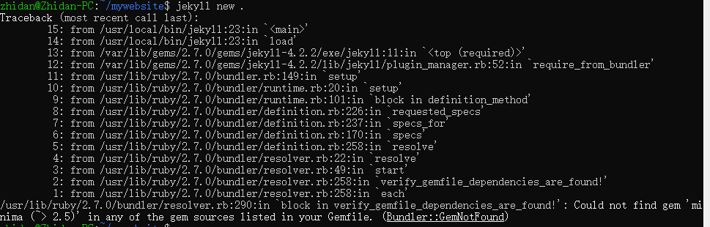

Well , I found the solution , if you have an issue like this : try to install :

gem install minima

&

gem install jekyll-feed

|  |
| --- |
| Install Jekyll Follow the instructions step by step as below: ****Step 1.**** Setup Ruby development environment first. $ sudo apt install ruby-full build-essential zlib1g-dev    **build-essential**: this will install required dependency needed to execute ruby environments.  **zlib1g-dev**: this package includes development files. Mostly they are header files in C and C++ languages. ****Step 2.**** Configure Ruby gems path and install Jekyll. In this step, I will set up my directory to install Ruby gems in a specific folder. I will also add environment paths and then source the **~/.bashrc**. This is how I populated environmental variables in Debian Linux. ****Step 3.**** Install Jekyll and Bundler Now I will install Jekyll and its companion gem “bundler” which is very helpful to keep gems updated.    Voila! Here we are with our all-installation process. ****Step 4.**** Now create a new folder for our static site and enter into it. You will need the following commands to do so. Please refer to the given screenshot.   ****Step 5.**** Create a new Jekyll website in a new folder. Process Jekyll command as shown below and create the site in our newly created folder. As shown below **~/myWebsite**   ****Step 6.**** Run the build and see your website live on <http://localhost:4000/>   Jekyll is now running with its full power.   Remove Jekyll Why would you remove Jekyll? Maybe you don’t need it. Anyway, It is simple to remove Jekyll. You would need to run the following commands to remove it.  $ gem remove jekyll |

**5. github pages**